Guide to use Weboctave

1. Follow the instructions mentioned in README or use the installation script.

2. Next, add @dispatch class to the loadpath of Octave.

3. If you have gui which opens up by issuing octave command, then rename the octave to octave-gui and then rename octave-cli to octave so that by default it now opens the octave-cli.

4. Now you can use the Weboctave as an anonymous user or can create your account.

5. One can define functions and can call them and can even download plots.

6. User can generate documentation by using doxygen.

For this cd path/to/this directory and then run doxygen doxygen.conf.

Let's Begin.....

When you open the interface for the first time, you'll be greeted by a default query:

A = [1,2;3,4]
eig(A)
y = x = linspace(0,10);
[X,Y] = meshgrid(x,y);
mesh(X,Y,sin(X).*cos(Y).*X);

Click on "Submit to Octave" and you'll be able to see plot and you can download it.

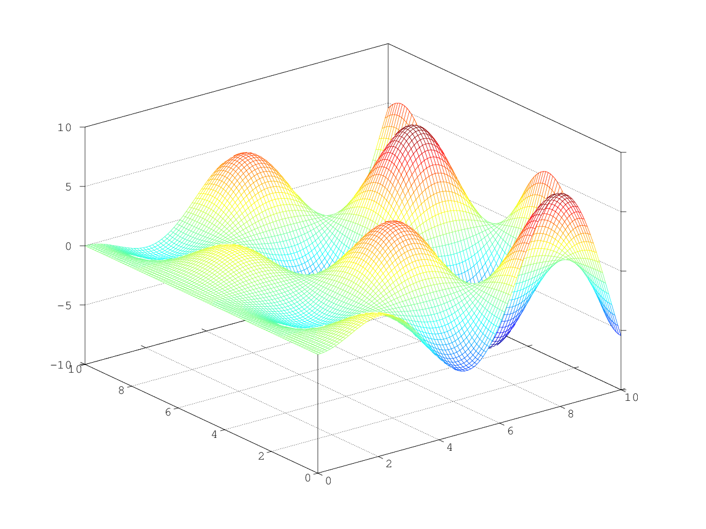

Under the Account menu, you can setup your username and password and all your files will be stored under the same account.

Under Functions menu, one can define new functions as one does in Octave and can see functions that are already defined.

Click on the clear button in order to clear the previous command.

